Lesson 9
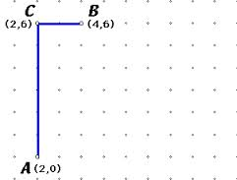
Distance between two points:
Distance between C and B
CB= |2-4|
|-2|= 2
Distance between C and A
CA= |6-0|
|6|= 6
On the grid you can also just count the units between the points.
If you need to measure the distance between two points that are not on a vertical or horizontal line then use the Distance Formula.

DISTANCE FORMULA (Derived from the Pythagorean Theorem)
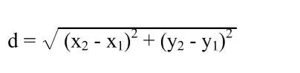

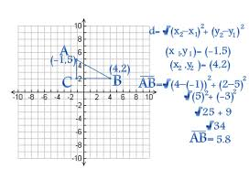
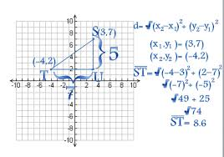
Plug in the coordinates from points A and B into
the distance formula.
(notice point B’s number was first in the x’s so B’s y
Should be first in the y’s)

Distance between points T
and S.

