Lesson 6
Identifying Pairs of Angles

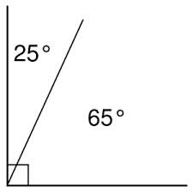
- Complementary Angles—2 angles whose sum is 90 degrees.

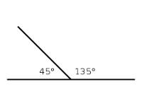
- Supplementary Angles—2 angles whose sum is 180 degrees.

- Adjacent angles—2 angles in the same plane that share a vertex and a side.

See 1 and 2

- Linear pair—adjacent angles whose non-common sides are opposite rays

Congruent Complements Theorem

If 2 angles are complementary to the same angle or to congruent angles, then they are congruent.
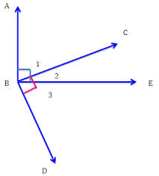

Congruent Supplements theorem

If two angles are supplementary to the same angle or to congruent angles then they are congruent.
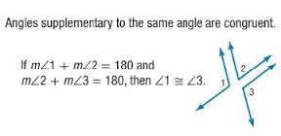

Linear pair Theorem

If two angles form a linear pair, then they are supplementary.

Vertical Angle theorem

If two angles are vertical angles, then they are congruent.
