Lesson 4 Notes
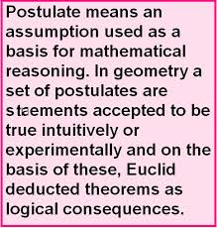
Postulates:

- Through any two points there is exactly one line.

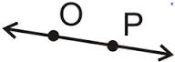
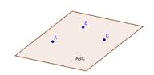

- Through any three noncollinear points there exists exactly one plane.

- If two planes intersect, then their intersection is a line.

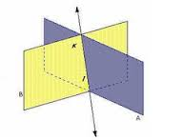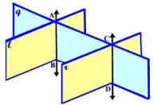
- If two points lie on a plane, then the line containing the points lies in the plane.

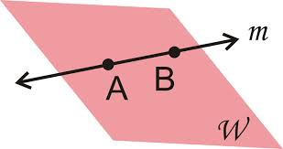
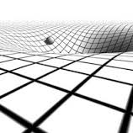
- A line contains at least 2 points. A plane contains at least 3 noncollinear points. Space contains at least 4 noncoplanar points.
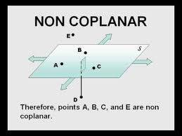

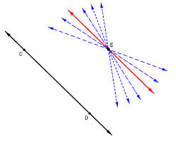
- Through a point not on a line, there exists exactly one line through the point that is parallel to the line.

Theorems (Theorems are proven to be true)

- If two lines intersect, then they intersect at exactly one point.
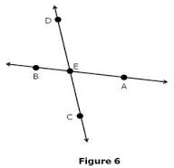

- If there is a line and a point not on the line, then exactly one plane contains
them.
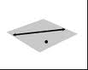

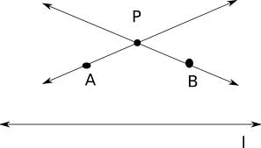
- If two lines intersect, then there exists exactly one plane that contains them.

- If two parallel planes are cut by a third plane, then the lines of intersection are parallel.

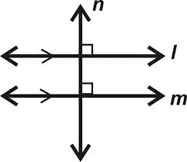
- If two lines in a plane are perpendicular to the same line, then they are parallel to each other.

- In a plane, if a line is perpendicular to one of two parallel lines, then it is perpendicular to the other one.
See # 5
- If two lines are perpendicular, then they form congruent adjacent angles.

- If two lines form congruent adjacent angles, then they are perpendicular.
See # 7
- All right angles are congruent.

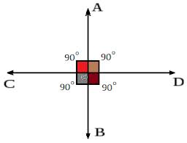

- If two lines are parallel to the same line, then they are parallel to one other.
