Lesson 3
Angles

Ray—a part of a line that starts at an endpoint and extends infinitely
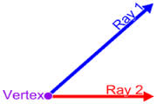
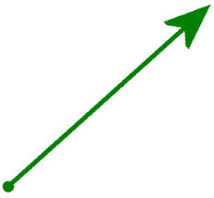

Opposite ray—two rays with a common endpoint that form a line

Angle—a figure formed with two rays with a common endpoint

Vertex—a common endpoint of an angle

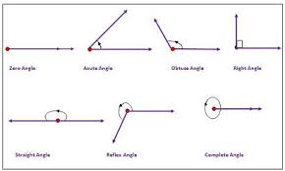
Sides—rays that are the sides of an angle

Protractor—a tool used to measure angles

Acute angle—an angle that is larger than 0 but less than 90 degrees
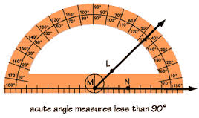
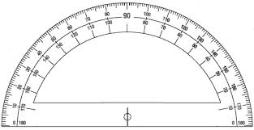

Obtuse angle—an angle that is larger than 90 but less than 180 degrees
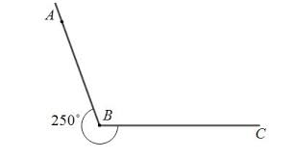

Right angle—this angle measures 90 degrees

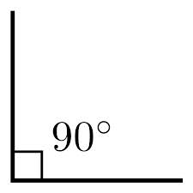

Straight angle—this angle measures 180 degrees

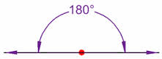

Bisect—to divide a figure into two congruent parts

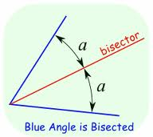

Angle bisector—a ray that divides the angle into two congruent angles

Congruent angles—they have the same measure and are the same size.

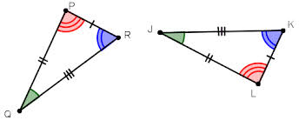

Arc marks—these are used to show congruent angles, which have the same measure

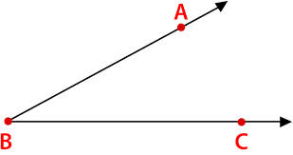
Naming Rays and Angles--
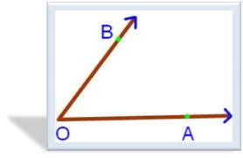

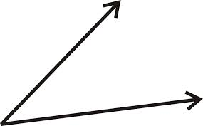
Measuring angles—
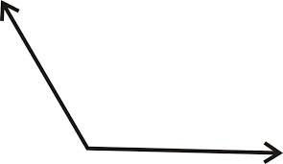

Adding angles
