Lesson 2
Line segment—part of a line consisting of two endpoints A and B.
Congruent—two geometric objects that have the same size and shape.
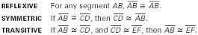
Congruence statement—shows that two segments are congruent.

Postulate—statement that is accepted as true without proof.
Segment addition postulate
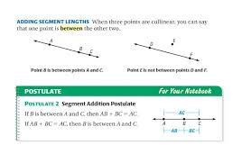
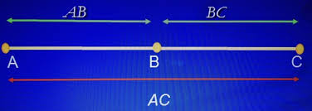

Distance—is the measure of the segment connecting two points.
Midpoint—is the point that divides the segment into two congruent parts.

