Lesson 13
Introduction to Triangles

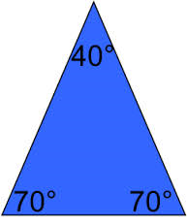
Acute Triangle—all angles measures less than 90 degrees

Obtuse Triangle— one angle measures less than 180 but greater than 90 degrees
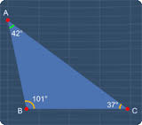
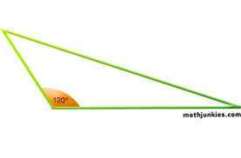

Right Triangle—measures 90 degrees
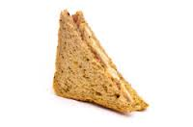
Yum!!
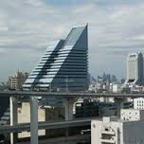

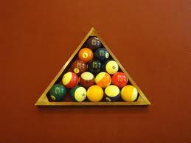
Equiangular Triangle—All three angles are equal in measure
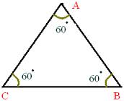

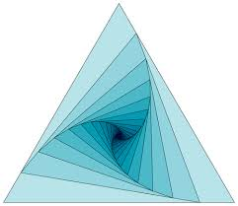
Equilateral Triangle—all three sides are equal in measure

Isosceles Triangle—two sides are equal in measure
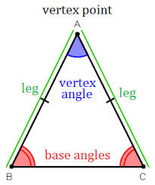

Scalene Triangle—no sides are equal in measure
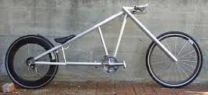
Parts of the Triangle
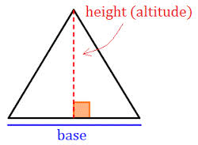

Vertex—One of the points where two sides of the triangle intersect
Base—Can be any one of the triangle’s sides
Heightz—perpendicular segment from the vertex to the line containing the opposite side.
Area of a Triangle
A=1/2BH where A =Area
B=Base
H=Height

