Lesson 12
Proving Parallel lines

Converse of the Corresponding Angles Postulate
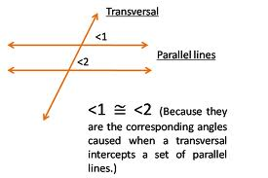
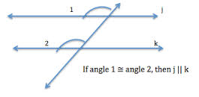

Converse of the Alternate Interior Angles Theorem

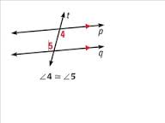
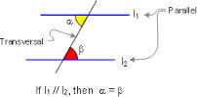

Converse of the Alternate exterior Angle Theorem
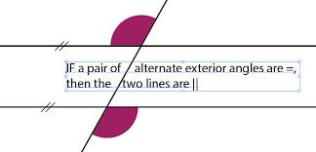

Converse of the Same Side Interior Angle Theorem
